**Abstract:**

Banking and technology are very closely associated and innovations have changed banking drastically over the period of time. The digital innovations in the banking sector started with the introduction of money that replaced the barter system and then the gradual replacement of wax seal with digital signatures. One such disruptive innovation which is changing the banking sector globally is Blockchain Technology (BCT). Blockchain is shared distributed ledger which stores business transaction to a permanent unbreakable chain which can be viewed by the parties in a transaction. Blockchain technology has the potential to disrupt the financial business applications as it provides permanent and tamper proof recording of transactions in a distributed network. It can be widely applied in digital currency, trade finance, and KYC etc. Although the potential of blockchain is enormous, it has various limitations of security, privacy and scalability which need to be addressed. The aim of this paper is to provide the overview of blockchain technology with its benefits and emphasizing on the applications of the technology in the Indian Banking Sector. The paper gives the insight of various challenges and global perspective of blockchain technology in Banking Industry. The utility of Blockchain is that financial transactions no longer require any central authority and are immediately validated, cleared and settled. Blockchain technology appears to be an innovation which promises a major change for capital markets and other financial services.

**About the Organization**

The main focus of the Candid Techno Solution company is on developing a business model that has a clear idea on providing a cost-effective software and application to all of the clients’ around the world. They believe in using the creativity and strong potential in providing website and other application solutions with including of easy to access and more compatible. It’s a fun to work in a company where employees truly believe in what actually they are doing. The company have a strong work-life balanced environment and trust the employees to do their job effectively. The company need to add innovate and bright people to the teams to help us continue to succeed and grow.The regularly work with all kind of businesses and the great industry knowledge to deal with all kinds of clients in the industry market.



**The Process**

* Analyze
* Develop
* Execute
* Evaluate

**The Quality Assurance**

* Service
* Efficiency
* Reliability
* Standard

**The Vision**

Our focused commitment to strong approach and process, we aim to go beyond the clients’ expectations.

**The Mission**

We Develop application and software to face the real-world business challenges, that will provide continues support to all of our clients.

**Services**

* Application development
* Infrastructure Management
* Web designing
* Mobility Solution
* Cloud Computing
* product Engineering services
* Big Data
* Business Intelligence

**Organization Chart**

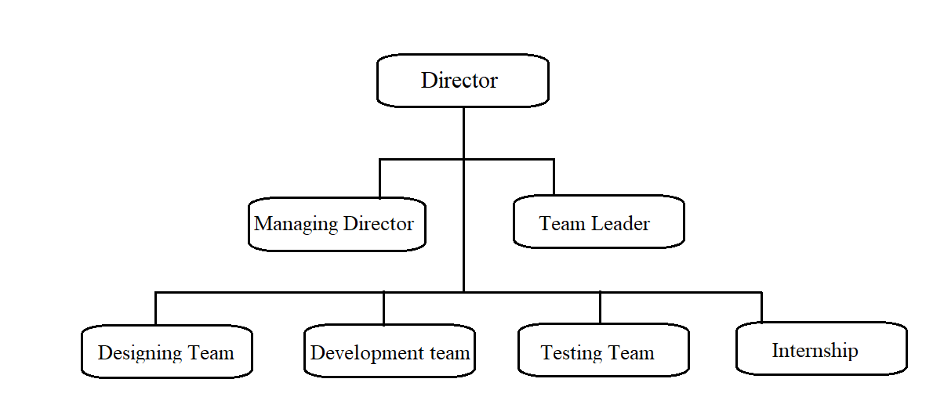

**Student Project Assignment and Responsibility**

As an Intern, my role in the organization is to understand the actual problem and help the developers in designing, coding and testing. The project which is assigned to me is Web Application for Dynamic concealment in recital visual block chain.

**CHAPTER 1**

**THE PROBLEMS**

**1.0 Introduction**

In this chapter the existing system is explained in detail along with the proposed solution. A detailed study has been done on the existing system and by referring lots of web resources, the idea of using the proposed technology and language were selected based on the problems to be overcome and the features of the web application.

**1.1 Description of the problem**

The banking sector stands to gain a lot by replacing their outdated systems for settling transactions with the newest offerings from the likes of Ripple and its competitors. Ripple is designed to be a high throughput blockchain which could handle upwards of 1500 transactions per second. Ripple achieves this by sharing the authentication privileges with a limited number of trusted nodes that can be run by banks themselves or public institutions such as universities. This gives banks with official records of asset ownership as the authenticators are legally responsible for processing transactions honestly. Switching over to Ripple’s xRapid service could help expedite their transaction settlements many times over while at the same time reducing their costs by over 40%. Ripple’s two main offering for bank-to-bank transfers are xCurrent and xRapid. xCurrent similar to the SWIFT messaging system and allows for settlement in cross-border payments but still requires traditional banking accounts to be held by participating banks. The real benefits of blockchains can, however, be seen in the xRapid system which utilizes Ripple’s native XRP token. xRapid significantly improves speed and reduces costs for cross-border payments by using XRP as a bridge asset between currencies thus eliminating the need for traditional banking accounts. But the problem with Ripple Blackchain is that Ripple seems to have legal problems as the company deals with several Database concerning various issues including registration violation and data loss. The most long-standing problem is the matter concerning the nature of XRP Server which created the XRP token.

**1.2 Objective:**

The applications provide the most faster and quick access of the banking process to deliver more value to the customers. It includes security, Validation, less processing time, tracking, This application integrates with the interactive help support from support team.

**The following services were used to develop the Web Application:**

* Customers will register with the User Id and Password.
* To know the status of the Account.
* Remind the customers about the information through the notification.
* Know the details of the previous transaction.
* Update the upcoming schedule.
* Provides high authentication and data security.

**1.3 Description of Existing System**

The below details illustrates about the existing problem solution of the project.

**1.3.1 Mobile Banking**

A banking app is a mobile app where you can access the details of your bank account and complete transactions directly from your phone, tablet, or mobile device. Based on the bank you’re accessing, you’ll be able to complete a variety of actions via your banking app. mobile banking apps can warn you when you spend more than you have in your account, automatically move money into savings on your payday and let you set controls on your cards to restrict spending. The apps can also send you account alerts, let you tap a button in a bank app to call a customer service representative and pay back a friend. Using a mobile banking app increases ease of use, speed, flexibility and also improves security because it integrates with the user built-in mobile device security mechanisms. From the bank's point of view, mobile banking reduces the cost of handling transactions by reducing the need for customers to visit a bank branch for non-cash withdrawal and deposit transactions. Some banks offer different mobile apps for different banking services. For instance, the bank may offer an e-Passbook app that only serves the purpose of account balance check since the app acts like a digital passbook and there is another mobile app for other services such as funds transfer, bill payment, and more in addition to balance check.

**1.3.2 Reply Blockchain App**

Blockchain offers an innovative approach to storing information, executing transactions, performing functions, and establishing trust in an open environment. Many consider blockchain as a technology breakthrough for cryptography and cyber security, with use cases ranging from globally deployed crypto currency systems like. This paper presents a comprehensive overview of the security and privacy of blockchain. To facilitate the discussion, we first introduce the notion of blockchains and its utility in the context of Bitcoin like online transactions. Then we describe the basic security properties that are supported as the essential requirements and building blocks for Bitcoin like crypto currency systems, followed by presenting the additional security and privacy properties that are desired in many blockchain applications. Finally, we review the security and privacy techniques for achieving these security properties in blockchain-based systems, including representative consensus algorithms, hash chained storage, mixing protocols, anonymous signatures, non-interactive zero-knowledge proof, and so forth. We conjecture that this survey can help readers to gain an in-depth understanding of the security and privacy of blockchain with respect to concept, attributes, techniques and systems.

**1.3.3 Bank balance enquiry**

All Bank Balance Enquiry app will help you to give a miss call to the official number of your bank and in turn the bank will reply via SMS with your account balance. Through this app you can avoid the use of internet banking and frequent visit to ATM counter to check your balance. The most astounding feature of this app is that you do not need internet to use this app and the number listed in this app is toll free that means All Bank ATM Balance Checker is completely free by all means. This app covers most of the Indian banks.With this app you can also solve your query related to your bank account by just giving a call on a Customer care number. Bank balance check app provides most of the banks Official missed call numbers. Bank Balance Inquiry enables you to view your bank account balance, mini statement & customer care number with just a single tap. All Bank Balance Enquiry app provides following details. IFSC Code: Get IFSC code for all banks of INDIA. Balance Enquiry: You can get all banks balance enquiry at one place and free of cost, Just choose you bank click on call (its free of cost miss call service for most of banks) you will get an sms from bank on your registered mobile number.

**1.4 Evaluation of Existing System**

The below details illustrates about the evaluation of existing system

**1.4.1 Mobile Banking**

mobile banking apps can warn you when you spend more than you have in your account, automatically move money into savings on your payday and let you set controls on your cards to restrict spending. The apps can also send you account alerts, let you tap a button in a bank app to call a customer service representative and pay back a friend.

**Advantages**

* Accessing the bank 24/7
* Optimizing your money
* Paying IOUs
* Strengthening security
* Providing added controls
* Offering clarity of where your financial data is going
* Giving you tailored options

**Disadvantages**

* frustrated with a digital banking
* Navigating the apps can feel daunting
* Cash gets lock at some time
* Not all mobile banking apps work well

**1.4.2 Reply Bockchain**

The app allowed users to insert pre-defined replies called "Smart Replies" into conversations on messaging apps on their phone such as Facebook Messenger, Slack and Google Hangouts.

**Advantages**

* Provide High Security
* Low Fragmentation And Easy Testing
* Allow To Penetrate Developed Countries Markets
* Secure Transactions

**Disadvantages:**

* Use excessive energy
* Implementation of cyber security is difficult
* Huge distributed computing system
* Mining does not provide network security
* Entries do not last forever or are not immutable

**1.4.3 Bank balance enquiry**

All Bank Balance Enquiry app will help you to give a miss call to the official number of your bank and in turn the bank will reply via SMS with your account balance. Through this app you can avoid the use of internet banking and frequent visit to ATM counter to check your balance.

**Advantages:**

* Ease of Banking
* Available 24*7
* Multipurpose

**Disadvantages:**

* Chances of Fraud
* Non Availability of Internet
* No Personal Touch

**1.5 Description of Other possible Solution**

The below details illustrates about the description of proposed system.

**1.5.1 Secure Banking**

The possible solution is to develop Blockchain technology is a new technology which is based on mathematical, cryptographic and economic principles for maintaining a database between various participants without the requirement of any third party or central authority. It is a secured distributed database, tamper evident, wherein the validity of a transaction can be verified by parties in the transaction. Each group of these transactions is referred to as a “block”. A Block records some or all of the recent transactions and goes into a blockchain as a permanent record once completed.

**1.5.2 Banking help**

Provide the overview of blockchain technology with its benefits emphasizing on the applications of the technology in the Indian Banking Sector. The paper gives the insight of various challenges and global perspective of blockchain technology in Banking Industry. The help desk for the users can also be used in the site itself. Live content updates make last minute changes immediately available on the app.

**1.6 Evaluation of Other Possible Solution**

The below details illustrates about the evaluation of proposed system.

**1.6.1. Secure Banking**

Data once stored cannot be tampered, updated or deleted. History of changes to the data is maintained and any previous updating to the data can be easily traced by the tracker code.

**Adavntages**

* Reduced Transaction Costs
* Trustworthy Distributed Systems
* Improved Security & Financial Efficiency
* Instant Payments at Reduced Costs

**Disadvantages**

* It cannot do low level stuff like interfacing directly with hardware through drivers and firmware.
* It doesn't come with a standalone compiler that can directly interpret the higher levels of the language.

**1.6.2 Banking help**

The main purpose of the project is to quick and fast process for the particular event. It is designed to offer an easy, fastest way to access banking. The application provides the high data transfer and support to the user and also can provide the help section in 24/7 .

**Advantages**

* Easy to access from any location.
* Application is user friendly.
* Good support for distributed system.
* Increased Stability

**Disadvantages**

* Security issues
* While the user tries to download multiple files at once there may be issues of system performance degradation.

**1.7 Conclusion**

In this chapter, the background details of the company, organization chart and a brief Description of the problem, objectives, description and evaluation of the existing system and Proposed system have been discussed. The other possible ways to solve the problem and importance of proposed system comparing to other possible solution is also discussed.

This leads to the design phase which is briefly explained in the next phase.

**CHAPTER 2**

**DESIGN**

## **2.0 Introduction**

Systems design is the process of defining the [architecture,](https://en.wikipedia.org/wiki/Systems_architecture) modules, interfaces, and [data](https://en.wikipedia.org/wiki/Data) for a [system](https://en.wikipedia.org/wiki/System) to satisfy specified [requirements.](https://en.wikipedia.org/wiki/Requirement) Systems design could be seen as the application of [systems theory](https://en.wikipedia.org/wiki/Systems_theory) to [product development.](https://en.wikipedia.org/wiki/Product_development) System design gives the entire picture of the application and interactions of its components.

**2.1 Project Plan**

## 

|  |  |  |  |  |
| --- | --- | --- | --- | --- |
| **PHASE** | **NAME** | **DESCRIPTION** | **START DATE** | **END DATE** |
| Phase I | Analysis | Understanding the problem, existing solution and defining the proposed Solution | 19.01.2021 | 23-02-2021 |
| Phase II | Design | Designing the project | 24-02-2021 | 02-03-2021 |
| Phase III | Implementation | Coding and  Implementing | 03-03-2021 | 19-03-2021 |
| Phase IV | Testing | Testing the system | 21-03-2021 | 30-03-2021 |
| Phase V | Documentation | Preparing the document | 01-04-2021 | 05-04-2021 |

*Table 2.1 Overall plan*